UNIT INFORMATION

UNIT OF STUDY: | 91402 Anatomical Pathology
ASSESSMENT TYPE: | individual submission
MARKS: | 100 marks
WEIGHTING | 30%
DUE DATE: | The Sunday end of week 8 - 23:59

Topic – Carbohydrate and Mucosubstances – Stain Report

To register for a topic
To register for this assignment chose one of the four tissues below.

Tissue 1
Main – Stromal Extracellular Matrix
Tissue 2
Main – Mesothelioma
Tissue 3
Main – Cartilage
Tissue 4
Main – Prostate

Then go to https://canvas.uts.edu.au/courses/19199/groups#tab-5811 and allocate yourself to the specific tissue type. Not: only 22 places for each tissue type – so first in gets first choice of tissue).

See the diagram below, to register follow the numbered steps in the diagram. First Cclick on the arrow head on the left-hand-side menu ‘People’ (Step 1) then choose the 2nd top tab ‘Stain Report’ (Step 2), next the ‘Tissue’ on which you wish to do your report (Step 3). This opens a rectangle below the ‘Tissue’. Next find your name in column on left (scroll- Step 4) then drag your name into the rectangular box you opened before below the ‘Tissue’ type you chose (Step 5).
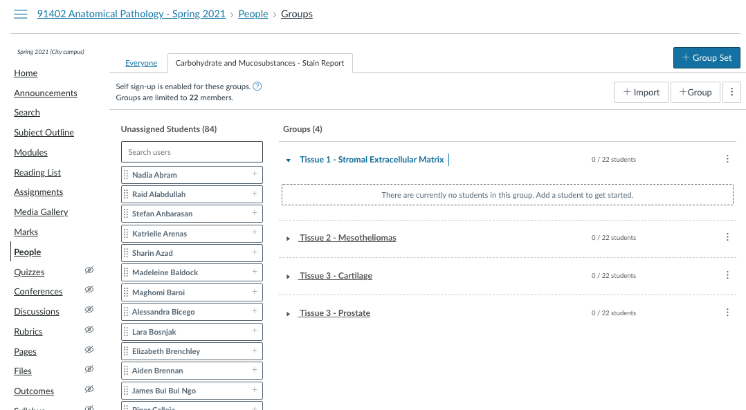
5
4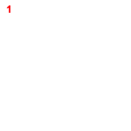
3
2
1

The Report
To complete your report you will need to download the ‘Report Template’ here you will be able to answer questions in template the sections. Do not alter the template.

Please use the template provided and do not exceed the word limit by more than 10%.

Report Sections
For any one of these tissue types you have chosen fill in the provided template document as described
Below are details of what is required in each section of the report, the template only has a short summary of what is detailed below
- Part 1
  - Describe what this tissue is composed of and what it would look like stained by the routine H&E method (Harris’ haematoxylin) – remember that different tissues/locations may change how the dyes of this technique are taken up – depending on the proportion of the component structures
  - Provide images (appropriately citing sources) to show this, remember to label the components and provide a figure number, figure title and legend describing what is shown.
- Part 2
  - For this tissue which of carbohydrate and mucosubstance staining/labelling technique would the best method to highlight this tissue’s carbohydrate rich components?
  - Describe the chemistry of the method and the nature of the carbohydrate/mucosubstance it is staining in your chosen tissue.
- Part 3
  - When and why would this technique be used for histopathological diagnosis?
  - What technical (laboratory processes) need to be considered when using this method? (Safety implications? Specific temperature/pH/timing/etc.?)
  - What advantage does this method have over other techniques for carbohydrates or mucosubstance staining/labelling procedures.
  - Is this method conclusive or indictive for a final diagnosis when ordered by the pathologist?
- Part 4
  - Are there any other techniques described in the last 5 to 10 years (2011 – 2021) that are either better or more definitive to show up this tissue’s carbohydrate or mucosubstance components. (A table may be useful here)
  - If there is no new method please provide the last published protocol. (remember to cite the source and put it in your reference list)
- Part 5
  - Bibliography

Plagiarism - Your report when submitted into Canvas will go through Turnitin to check for similarity.

N.B.
- Clarity and succinct expression are required in all responses.

Instructions
- The assessment should be completed in your own words with the information being clear, concise and easy to understand. Please avoid using direct quotes or definitions from other resources.

Material should be obtained from at least five other sources (other than the set text) which could include reference textbooks, web sites or research papers (academic) among others. Please do not use Wikipedia.
- All information presented in the answer must be correctly referenced following the APA or Vancouver styles.
- Any diagrams must also be properly referenced as separate pieces of information.
- Information on how to use Vancouver or APA referencing can be obtained from the library.

Presentation (Use the Word template provided!)
- Ensure you keep copies of your document and versions in at last3 locations, your PC/laptop, Onedrive and a thumb drive, so there is no excuse for losing your work.
- This assessment must be typed. Arial [11] font; single or 1½ line spaced.
- Assignment must have a cover page that contains your name, student ID and assignment title.
- Each page of the submitted assignment must have student name and student number in the footer.
- Please be factual, concise and clear in answering your questions and try using the least amount of words possible to demonstrate your deep understanding of the information.
- Use of correct spelling and grammar is expected. Do not mix English with American English spelling or terminology, chose one or the other and stick to it.

Submission of the assignment
- Convert the Microsoft Word template completed in all its parts as a .PDF file.
- Rename the file as follows: Subject code_SID_Student name_last name (i.e. 91812_12345678_Jane_Doe.PDF).
- The assignment has to be submitted as a single document for each student.
- Each submission will have a Turnitin score which will automatically be determined in Canvas.
- The completed assessment is due no later than 23:59 of the Sunday at the end of week 8.
- If the student requires an extension, then this it at the discretion of the subject coordinator and should be applied for well in advance (minimum 2 weeks before) the due date by discussion with the subject coordinator and by completing and submitting a formal request with reasonable causes for the request of extension. Late assignment submissions without any previously arranged extensions will incur 10% deduction of the final mark penalties per each day.

